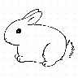 1. Give someone a hug. 16. Say, “Thank you!” for Easter
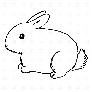2. Play with someone outside. 17. Clean the yard.
3. Say, “Thank you’. 18. Draw a picture for someone.
4. Give a compliment. 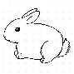19. Clean your room.
5. Pick up your toys 20. Help a family member.
6. Ask someone to take a walk with you. 21. Say, “I Love.”
7. Share your toys. 22. Pick up toys.
8. Tell a joke. 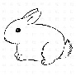23. Say, “Goodnight.”
9. Blow a kiss. 24. Set the table.
10. Fold the laundry 25. Give a compliment.
11. Smile! 26. Ask someone if they need help.
12. Say, “I love you.” 27. Give a hug.
13. Pick up litter. 29. Put your clothes away.
14. Make your family an Easter Card. 30. Blow a kiss. 15. Help a parent or a sibling.

